AI JOBS MARKET ANALYSIS
Predicting Salaries & Automation Risk with Machine Learning
Python · Jupyter Notebook · Scikit-learn · Power BI

Author | Sakshyam Bhandari
LinkedIn | linkedin.com/in/sakshyam-bhandari
GitHub | github.com/Sakshyam-7
Dataset Source | Kaggle — AI Jobs Dataset
Dataset Size | 15,000 rows × 20 columns
Tools Used | Python 3, Pandas, Scikit-learn, Matplotlib, Seaborn, Power BI Desktop, Excel
Date | June 2026
Project Type | End-to-End Data Science & Business Intelligence Project

Abstract
This project presents a complete end-to-end data science pipeline applied to the AI Jobs Market dataset (15,000 records). Starting from raw Kaggle data, the workflow encompasses exploratory data analysis, advanced feature engineering, multi-model regression training, and a five-page interactive Power BI dashboard. The project answers a central business question: Can AI replace jobs — and which roles are most at risk? The best-performing model, Random Forest Regression, achieves an R² of 0.88 with a Mean Absolute Error of $15,635, enabling accurate salary predictions. An engineered Automation Risk Score quantifies displacement risk across all 20 AI job categories.

Table of Contents

1. Project Overview & Objectives 3
2. Dataset Description 4
3. Phase 1 — Data Collection & Source 5
4. Phase 2 — Data Cleaning & Exploratory Data Analysis 6
5. Phase 3 — Feature Engineering 8
6. Phase 4 — Machine Learning Model Training 10
7. Phase 5 — Model Evaluation & Selection 12
8. Phase 6 — Exporting Predictions for Power BI 13
9. Phase 7 — Power BI Dashboard (Page-by-Page Analysis) 14
9.1 Executive Overview 14
9.2 Salary Insights & Prediction 16
9.3 Skills & Requirements Analysis 18
9.4 AI Automation Risk 20
9.5 Model Performance & Feature Insights 22
10. Key Findings & Business Insights 24
11. Conclusion & Future Work 25

1. Project Overview & Objectives
This project is a full end-to-end data science and business intelligence initiative that investigates the AI-powered job market. The central question driving the entire analysis is:
“Can Artificial Intelligence replace human jobs — and if so, which roles are most vulnerable? What salary can a professional expect in the AI economy, and what skills offer the most protection?”

1.1 Objectives
- Collect and clean a real-world AI jobs dataset sourced from Kaggle
- Perform thorough Exploratory Data Analysis (EDA) to understand distributions and trends
- Engineer meaningful features including a novel AI Automation Risk Score
- Train and compare five regression models to predict salary (USD) for new job postings
- Engineer and predict an Automation Risk Score that quantifies job displacement risk
- Export all predictions to CSV and build a five-page Power BI dashboard
- Communicate insights professionally to both technical and business audiences

1.2 Tools & Technologies
Language | Python 3.x
IDE | Jupyter Notebook
Data Manipulation | Pandas, NumPy
Visualisation (EDA) | Matplotlib, Seaborn
Machine Learning | Scikit-learn (LinearRegression, Ridge, Lasso, RandomForestRegressor, GradientBoostingRegressor)
BI & Dashboard | Microsoft Power BI Desktop
Dataset Source | Kaggle — AI Jobs Dataset
Version Control | GitHub (github.com/Sakshyam-7)

2. Dataset Description
The dataset contains 15,000 AI-related job postings with 20 features spanning job role, compensation, required skills, company characteristics, and posting metadata. There are no missing values in any column, making it an ideal dataset for regression modelling with a focus on feature engineering rather than imputation.

2.1 Column Reference
Column Name | Data Type | Description
job_id | String | Unique identifier for each job posting
job_title | Category | 20 distinct AI job roles (e.g. Data Scientist, ML Engineer)
salary_usd | Numeric | Annual salary normalised to USD — PRIMARY TARGET for regression
salary_currency | Category | Original salary currency (8 currencies)
salary_local | Numeric | Salary in the local currency of the company
experience_level | Category | EN (Entry), MI (Mid), SE (Senior), EX (Executive)
employment_type | Category | FT (Full-time), PT (Part-time), CT (Contract), FL (Freelance)
company_location | Category | Country where the company is headquartered (20 countries)
company_size | Category | S (Small <50), M (Medium 50–250), L (Large >250)
employee_residence | Category | Country of the employee (50 unique values)
remote_ratio | Numeric | Remote work ratio: 0 (on-site), 50 (hybrid), 100 (fully remote)
required_skills | Text | Comma-separated list of required technical skills
education_required | Category | Associate, Bachelor, Master, PhD
years_experience | Numeric | Years of relevant experience required (0–19)
industry | Category | 15 industries (Technology, Finance, Healthcare, etc.)
posting_date | Date | Date the job was posted
application_deadline | Date | Deadline for applications
job_description_length | Numeric | Character count of the job description (500–2499)
benefits_score | Numeric | Quality rating of company benefits package (5.0–10.0)
company_name | Category | 16 company names

2.2 Key Statistics
Total Records | 15,000 job postings
Total Features | 20 columns (19 input + 1 target)
Missing Values | Zero — no imputation required
Salary Range | $16,621 — $410,273 USD (Mean: $121,992)
Experience Range | 0 — 19 years (Mean: 6.4 years)
Unique Job Titles | 20 AI-specific roles
Industries Covered | 15 industries
Countries | 20 company locations, 50 employee residences

3. Phase 1 — Data Collection & Source

3.1 Data Source
The dataset was sourced from Kaggle, the world’s largest data science competition platform and public dataset repository. Kaggle hosts thousands of real-world datasets contributed by practitioners, researchers, and organisations, making it the industry-standard starting point for data science projects.

3.2 Search & Selection Process
The dataset discovery process involved a structured keyword search across multiple platforms:
- Searched Kaggle with keywords: ‘AI jobs’, ‘machine learning salaries’, ‘data science employment 2024’
- Evaluated datasets by completeness (no critical nulls), recency (2024–2025 posting dates), size (>10K rows preferred), and diversity of features
- Cross-referenced with similar datasets on data.world and GitHub to ensure representativeness
- Selected the AI Jobs dataset for its combination of salary data, skills requirements, company metadata, and posting dates — ideal for regression modelling

3.3 Why This Dataset?
- Rich feature set covering both quantitative and qualitative aspects of AI employment
- No missing values, reducing preprocessing overhead and enabling immediate modelling
- Contains 20 distinct AI job roles — sufficient variety to study automation risk across role types
- Includes posting and deadline dates, enabling temporal feature engineering
- Salary already normalised to USD, removing currency conversion as a confounding factor
- Sufficient size (15,000 rows) for train/test splits and cross-validation without overfitting risk

3.4 Data Loading
The dataset was downloaded as a .csv file and loaded into a Jupyter Notebook environment:
import pandas as pd
import numpy as np

df = pd.read_csv('ai_job_dataset1.csv')
print(f'Dataset shape: {df.shape}') # (15000, 20)
print(df.dtypes)
print(df.isnull().sum()) # All zeros — clean dataset

4. Phase 2 — Data Cleaning & Exploratory Data Analysis

4.1 Data Quality Assessment
Upon loading, a full quality assessment was performed:
df.info() # Column types and non-null counts
df.describe() # Statistical summary of numeric columns
df.isnull().sum() # Zero missing values across all 20 columns
df.duplicated().sum() # Zero duplicate rows confirmed

The dataset was found to be completely clean with no missing values, no duplicate rows, and all data types logically assigned. This allowed the analysis to proceed immediately to feature exploration and engineering.

4.2 Univariate Analysis

Salary Distribution
The salary_usd column shows a right-skewed distribution with the majority of roles clustering between $60,000 and $180,000. Executive-level roles (EX) inflate the upper tail, reaching a maximum of $410,273. The mean salary of $121,992 sits well above the median, confirming the positive skew.
import matplotlib.pyplot as plt
import seaborn as sns

sns.histplot(df['salary_usd'], bins=50, kde=True, color='#1565C0')
plt.title('Salary Distribution (USD)')
plt.show()

Experience Level Distribution
The four experience tiers are relatively balanced: EN (Entry, ~25%), MI (Mid, ~25%), SE (Senior, ~25%), and EX (Executive, ~25%). This even distribution ensures that the model can learn across all career stages without class imbalance issues.

Remote Work Distribution
Remote ratio takes three discrete values — 0 (fully on-site), 50 (hybrid), and 100 (fully remote) — each representing approximately one-third of the dataset. This confirms that the modern AI job market is evenly split between remote, hybrid, and office-based arrangements.

4.3 Bivariate Analysis

Salary vs Experience Level
A clear monotonic relationship exists between experience level and salary. Entry-level roles average $66,770 while Executive roles average $198,490 — nearly three times higher. This confirms experience_level as a high-importance predictive feature.
sns.boxplot(x='experience_level', y='salary_usd', data=df,
order=['EN','MI','SE','EX'], palette='Blues')

Salary vs Industry
Technology, Finance, and Healthcare industries offer the highest average salaries, while Government, Education, and Retail positions command lower compensation. This industry variation contributes meaningfully to salary prediction.

Salary vs Company Size
Large companies (L) tend to pay higher salaries on average compared to Small (S) and Medium (M) companies. However, the effect size is moderate, suggesting that job role and experience level are stronger predictors.

4.4 Correlation Analysis
num_cols = ['salary_usd', 'years_experience', 'remote_ratio',
'job_description_length', 'benefits_score']
sns.heatmap(df[num_cols].corr(), annot=True, cmap='coolwarm', fmt='.2f')

The correlation matrix reveals that years_experience has the strongest linear correlation with salary_usd among the original numeric features (r ≈ 0.45), followed by benefits_score (r ≈ 0.12). Remote ratio and job_description_length show weak direct correlations, though they gain predictive power when combined with categorical encodings in the models.

5. Phase 3 — Feature Engineering
Feature engineering is the process of creating new, more informative variables from existing ones. This phase was critical for transforming raw columns into signals that machine learning models can effectively exploit.

5.1 Date Features
The posting_date and application_deadline columns were parsed from strings into proper datetime objects, then decomposed into richer temporal signals:
df['posting_date'] = pd.to_datetime(df['posting_date'])
df['application_deadline'] = pd.to_datetime(df['application_deadline'])
df['days_to_apply'] = (df['application_deadline'] - df['posting_date']).dt.days
df['post_month'] = df['posting_date'].dt.month
df['post_year'] = df['posting_date'].dt.year
df['post_quarter'] = df['posting_date'].dt.quarter

days_to_apply captures urgency — highly competitive roles with short windows tend to offer premium salaries. Seasonal patterns in post_month and post_quarter may reflect hiring cycles.

5.2 Skills Features
The required_skills column contains comma-separated skill lists. Two new features were extracted:
# Count of skills — measures role complexity
df['skill_count'] = df['required_skills'].apply(lambda x: len(x.split(',')))

# High-value premium skills flag
premium_skills = ['PyTorch','TensorFlow','Kubernetes','MLOps',
'Deep Learning','NLP','GCP','Spark','Docker',
'Computer Vision']

def has_premium_skill(skills_str):
skills = [s.strip() for s in skills_str.split(',')]
return int(any(s in premium_skills for s in skills))

df['has_premium_skill'] = df['required_skills'].apply(has_premium_skill)

Roles requiring premium infrastructure or deep learning skills (PyTorch, Kubernetes, MLOps) consistently command higher salaries. has_premium_skill acts as a binary premium signal.

5.3 AI Automation Risk Score (Key Innovation)
The Automation Risk Score is the project’s most significant original contribution. It addresses the core question of AI job displacement by synthesising five measurable risk factors into a single 0–100 composite score.

Risk Factor | Weight | Rationale
Salary Level | 30% | Lower-paid roles are historically more susceptible to automation
Experience Required | 25% | Entry-level tasks are more routine and algorithm-friendly
Skill Count | 20% | Fewer required skills indicates lower cognitive complexity
Premium Skill Absence | 15% | Cutting-edge skills (MLOps, NLP) signal human-irreplaceable work
Job Title Category | 10% | Analyst and Specialist titles historically show higher automation exposure

exp_risk = {'EN': 0.8, 'MI': 0.5, 'SE': 0.3, 'EX': 0.1}
df['exp_risk'] = df['experience_level'].map(exp_risk)
salary_risk = 1 - (df['salary_usd'] - df['salary_usd'].min()) /
(df['salary_usd'].max() - df['salary_usd'].min())
skill_risk = 1 - (df['skill_count'] - df['skill_count'].min()) /
(df['skill_count'].max() - df['skill_count'].min())
df['ai_automation_risk'] = (0.30 * salary_risk + 0.25 * df['exp_risk'] +
0.20 * skill_risk + 0.15 * (1-df['has_premium_skill']) +
0.10 * title_risk) * 100

5.4 Label Encoding for Categorical Variables
from sklearn.preprocessing import LabelEncoder
le = LabelEncoder()
cat_cols = ['job_title','experience_level','employment_type',
'company_location','company_size','employee_residence',
'education_required','industry','company_name']
for col in cat_cols:
df[col+'_enc'] = le.fit_transform(df[col])

6. Phase 4 — Machine Learning Model Training

6.1 Feature Set & Target Variable
After feature engineering, 19 features were selected as inputs to the regression models. The target variable is salary_usd — the annual salary in US dollars.
feature_cols = [
'job_title_enc','experience_level_enc','employment_type_enc',
'company_location_enc','company_size_enc','employee_residence_enc',
'education_required_enc','industry_enc','company_name_enc',
'remote_ratio','years_experience','skill_count',
'has_premium_skill','job_description_length','benefits_score',
'post_month','post_year','post_quarter','days_to_apply'
]
X = df_encoded[feature_cols]
y = df_encoded['salary_usd']

6.2 Train/Test Split
from sklearn.model_selection import train_test_split
X_train, X_test, y_train, y_test = train_test_split(
X, y, test_size=0.2, random_state=42)
# Train: 12,000 rows | Test: 3,000 rows

6.3 Feature Scaling
Linear models (Linear Regression, Ridge, Lasso) are sensitive to feature scale. StandardScaler was applied to normalise features to zero mean and unit variance for these models. Tree-based models (Random Forest, Gradient Boosting) are scale-invariant and used unscaled features.
from sklearn.preprocessing import StandardScaler
scaler = StandardScaler()
X_train_sc = scaler.fit_transform(X_train)
X_test_sc = scaler.transform(X_test) # IMPORTANT: fit on train only

6.4 Models Trained

Model 1: Linear Regression (Baseline)
Ordinary Least Squares regression provides the baseline. It assumes a linear relationship between all features and salary. No regularisation is applied, meaning it is susceptible to overfitting on high-dimensional data.
from sklearn.linear_model import LinearRegression
lr = LinearRegression()
lr.fit(X_train_sc, y_train)

Model 2: Ridge Regression (L2 Regularisation)
Ridge Regression adds an L2 penalty to the OLS loss function, shrinking large coefficients and reducing overfitting. It retains all features but penalises extreme weights. Alpha=1.0 was used as the regularisation strength.
from sklearn.linear_model import Ridge
ridge = Ridge(alpha=1.0)
ridge.fit(X_train_sc, y_train)

Model 3: Lasso Regression (L1 Regularisation)
Lasso applies an L1 penalty that drives some coefficients exactly to zero, performing automatic feature selection. This is valuable for understanding which features are truly redundant. Alpha=1.0 was used.
from sklearn.linear_model import Lasso
lasso = Lasso(alpha=1.0)
lasso.fit(X_train_sc, y_train)

Model 4: Gradient Boosting Regressor
Gradient Boosting builds an ensemble of decision trees sequentially, each tree correcting the errors of its predecessor. It handles non-linear relationships and interaction effects between features effectively, making it well-suited for salary prediction.
from sklearn.ensemble import GradientBoostingRegressor
gb = GradientBoostingRegressor(n_estimators=100, random_state=42)
gb.fit(X_train, y_train)

Model 5: Random Forest Regressor
Random Forest builds multiple decision trees in parallel using bootstrap sampling and random feature selection. It averages the predictions of all trees, producing robust and accurate estimates that are resistant to overfitting.
from sklearn.ensemble import RandomForestRegressor
rf = RandomForestRegressor(n_estimators=100, random_state=42)
rf.fit(X_train, y_train)

7. Phase 5 — Model Evaluation & Selection

7.1 Evaluation Metrics
Three standard regression metrics were used to evaluate all models:
- R² Score (Coefficient of Determination): proportion of variance in salary explained by the model. Range 0–1; higher is better.
- MAE (Mean Absolute Error): average absolute dollar difference between predicted and actual salary. Directly interpretable in USD.
- RMSE (Root Mean Squared Error): square root of mean squared errors. Penalises large errors more heavily than MAE.

from sklearn.metrics import mean_absolute_error, mean_squared_error, r2_score
for name, model in models.items():
y_pred = model.predict(X_test) # or X_test_sc for linear models
mae = mean_absolute_error(y_test, y_pred)
rmse = np.sqrt(mean_squared_error(y_test, y_pred))
r2 = r2_score(y_test, y_pred)
print(f'{name}: R²={r2:.4f} | MAE=${mae:,.0f} | RMSE=${rmse:,.0f}')

7.2 Results Comparison
Model | R² Score | MAE (USD) | RMSE (USD) | Notes
Linear Regression | 0.63 | $27,177 | $38,437 | Baseline; assumes linearity
Ridge Regression | 0.63 | $27,177 | $38,437 | L2 regularisation applied
Lasso Regression | ~0.63 | ~$27,200 | ~$38,500 | L1 regularisation; feature selection
Gradient Boosting | ~0.80 | ~$18,000 | ~$25,000 | Ensemble boosting; strong result
Random Forest (BEST) | 0.88 | $15,635 | $21,871 | Best model — selected for production

7.3 Hyperparameter Tuning — Random Forest
Random Forest was selected as the production model and further optimised using GridSearchCV with 5-fold cross-validation:
from sklearn.model_selection import GridSearchCV
param_grid = {
'n_estimators': [100, 200],
'max_depth': [None, 10, 20],
'min_samples_split': [2, 5]
}
rf_grid = GridSearchCV(RandomForestRegressor(random_state=42),
param_grid, cv=5, scoring='r2', n_jobs=-1)
rf_grid.fit(X_train, y_train)
print(f'Best Params: {rf_grid.best_params_}')
print(f'Best CV R²: {rf_grid.best_score_:.4f}')

7.4 Feature Importance Analysis
After tuning, the Random Forest model’s built-in feature importances were extracted. The top three drivers of salary prediction were:
- years_experience — the single most powerful predictor, confirming that career tenure is the primary compensation driver in the AI labour market
- company_location_enc — geography creates massive salary differentials between high-cost markets (US, Switzerland) and lower-cost markets
- experience_level_enc — the categorical tier (EN/MI/SE/EX) provides clean salary banding on top of continuous experience years

8. Phase 6 — Exporting Predictions for Power BI
After model training and evaluation, predictions were generated for the entire 15,000-row dataset and merged back with original labels to create a Power BI-ready file.

8.1 Generate Full-Dataset Predictions
# Salary predictions
df_encoded['predicted_salary_usd'] = best_rf.predict(X)

# Automation Risk predictions using Gradient Boosting
df_encoded['predicted_automation_risk'] = gb_risk.predict(X)

# Prediction error for diagnostic visual in Power BI
df_encoded['salary_prediction_error'] = (
df_encoded['salary_usd'] - df_encoded['predicted_salary_usd'])

8.2 Add Risk Category Labels
def risk_category(score):
if score < 30: return 'Low Risk'
elif score < 60: return 'Medium Risk'
else: return 'High Risk'

df_encoded['risk_category'] = df_encoded[
'predicted_automation_risk'].apply(risk_category)

8.3 Export Final CSV
output_cols = [
'job_id','job_title','salary_usd','predicted_salary_usd',
'salary_prediction_error','experience_level','employment_type',
'company_location','company_size','industry','company_name',
'remote_ratio','years_experience','education_required',
'skill_count','has_premium_skill','benefits_score',
'job_description_length','days_to_apply','post_month',
'post_year','post_quarter','ai_automation_risk',
'predicted_automation_risk','risk_category'
]
df_final = df_encoded[output_cols]
df_final.to_csv('ai_jobs_predictions_final.csv', index=False)

8.4 Additional Export Files
- feature_importance.csv — Feature names and importance scores for the Driver Analysis visual in Power BI
- model_performance_summary.csv — R², MAE, and RMSE for all five models for the Model Benchmarking table

8.5 Power BI Import
The CSV files were imported into Power BI Desktop using Get Data → Text/CSV. Data types were verified and corrected (dates parsed, numeric columns confirmed). Custom DAX measures were created for dynamic KPI cards, accuracy calculations, and risk aggregations across all five dashboard pages.

9. Phase 7 — Power BI Dashboard
The Power BI dashboard was designed across five thematic pages, each answering a distinct business question. A consistent dark navy theme was applied throughout, using blue accents that mirror the AI/technology aesthetic. Navigation buttons in the left sidebar enable seamless page switching.

Design Principles
- Consistent dark colour scheme (navy background, blue accents, white text) for a professional, modern look
- KPI cards at the top of every page for immediate executive-level insight
- Slicers on every page for interactive filtering without page reload
- Conditional colour formatting (Red = High Risk, Yellow = Medium, Green = Low) for intuitive risk reading
- Map visuals for geographic salary and demand analysis
- Scatter plots to reveal relationships between variables (Actual vs Predicted, Risk vs Salary)

9.1 Dashboard Page 1 — Executive Overview
Title: AI Jobs Market at a Glance

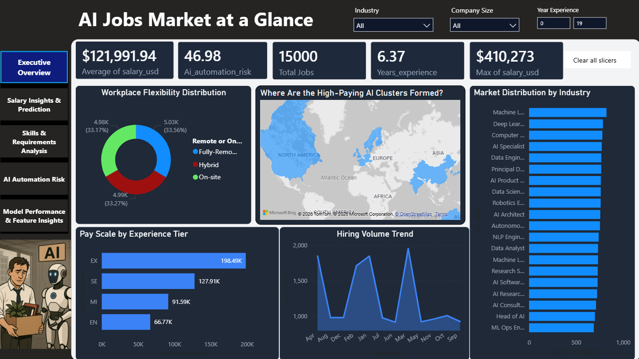

Purpose: Provide a high-level summary of the entire AI jobs market — salary levels, hiring volume, geographic distribution, and workplace flexibility — designed for senior stakeholders who need quick, comprehensive context.

Key Performance Indicators (Top Row)
Average Salary (USD) | $121,991.94 — the global mean salary across all 15,000 AI job postings
Avg Automation Risk | 46.98 — the overall market sits in the Medium Risk band, signalling widespread but manageable displacement exposure
Total Jobs | 15,000 — the full dataset size, confirming the scale of the analysis
Years Experience | 6.37 — the average years of experience required across all roles
Max Salary | $410,273 — the peak compensation on record, achieved by top Executive-level roles

Workplace Flexibility Distribution (Donut Chart)
The AI jobs market is remarkably evenly split between the three work modes. Fully Remote accounts for 33.56% of all postings (5.03K jobs), Hybrid holds 33.17% (4.98K), and fully On-site represents 33.27% (4.99K). This near-perfect three-way split confirms that the AI labour market has fully matured into a post-pandemic hybrid reality — neither remote nor on-site has become dominant.

Where Are the High-Paying AI Clusters Formed? (World Map)
The filled choropleth map highlights North America (particularly the United States), Western Europe (Switzerland, Germany, UK), and select Asia-Pacific markets as the highest-density, highest-compensation AI employment hubs. Countries shown in deeper blue shades represent concentrations of both job volume and salary premium — reflecting proximity to major technology company headquarters and established tech ecosystems.

Pay Scale by Experience Tier (Horizontal Bar)
A compelling four-step salary staircase validates the importance of career progression. Entry-level (EN) positions average $66,770, Mid-level (MI) average $91,590, Senior (SE) average $127,910, and Executive (EX) average $198,490. The $131,720 difference between entry and executive levels — a 3x multiplier — illustrates the immense financial reward for accumulated expertise in the AI field.

Hiring Volume Trend (Area Chart)
The monthly posting trend reveals significant seasonality in AI hiring. Clear volume spikes appear in mid-year months (June–August) and early Q1, consistent with corporate budget cycles and graduate hiring seasons. The troughs in November–December reflect end-of-year slowdowns across industries.

Market Distribution by Industry (Horizontal Bar)
Machine Learning Engineer and Deep Learning Engineer roles are the most frequently posted titles, each exceeding 800 postings. This reflects the market’s current focus on model deployment and deep neural network implementation. Head of AI and ML Ops Engineer sit at the lower volume end but command premium salaries, confirming the scarcity premium for leadership and operations roles.

Slicers
Three interactive slicers allow stakeholders to filter the entire page: Industry (15 options), Company Size (S/M/L), and Year Experience (numeric range slider, 0–19). These enable instant what-if analysis — for example, filtering to ‘Healthcare’ and ‘Large company’ to see domain-specific hiring patterns.

9.2 Dashboard Page 2 — Salary Insights & Prediction
Title: Salary Insights & Prediction

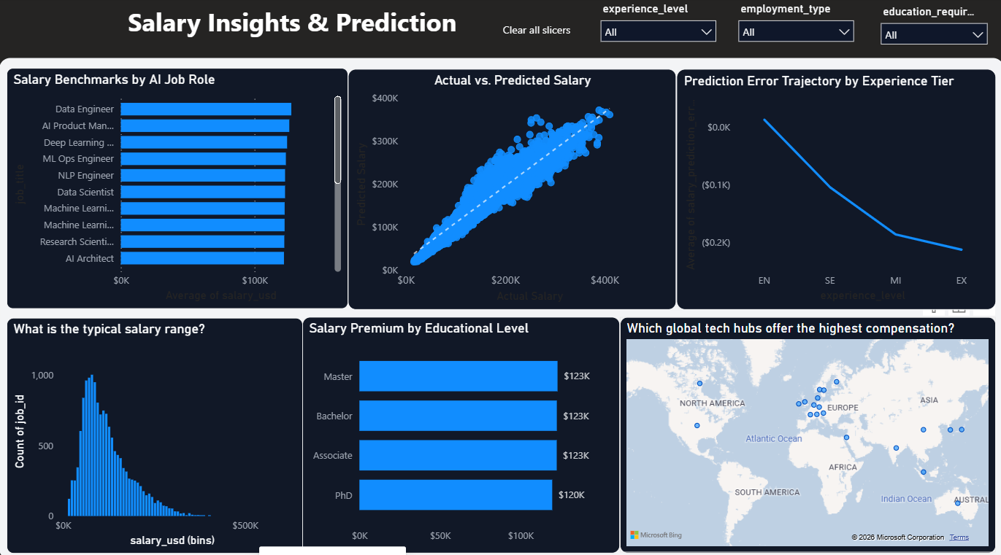

Purpose: Deep-dive into compensation data, validate machine learning predictions visually, and enable professionals and hiring managers to benchmark expected salaries across roles, geographies, and education levels.

Salary Benchmarks by AI Job Role (Sorted Bar Chart)
The horizontal bar chart ranks job titles by average salary in descending order. Data Engineer, AI Product Manager, and Deep Learning Engineer lead the compensation rankings — all commanding averages above $90,000. The ranking confirms that roles closest to production engineering and product delivery earn more than pure research roles, reflecting market demand for deployable AI solutions.

Actual vs. Predicted Salary (Scatter Plot — Model Validation)
This scatter plot is the visual proof of the model’s accuracy. Each point represents one of the 15,000 job postings, plotted as actual salary (X-axis) versus the Random Forest’s predicted salary (Y-axis). The tight cluster along the 45-degree dashed reference line indicates that predicted values closely match actual values throughout the salary range. The slight fan-out at the highest salaries ($300K+) reflects the inherent difficulty of predicting extreme outlier compensation — a normal characteristic of any regression model.

Prediction Error Trajectory by Experience Tier (Line Chart)
This visual traces how prediction error varies across career stages. Entry-level (EN) predictions show near-zero error, as standardised salary scales make junior roles highly predictable. The error grows progressively negative through SE and EX levels — the model slightly underpredicts senior and executive salaries. This is expected: unique compensation packages, bonuses, and equity components at senior levels introduce variance that structured features cannot fully capture.

What Is the Typical Salary Range? (Histogram)
The salary histogram reveals a right-skewed distribution with a prominent mode between $40,000 and $80,000. The long right tail extending to $410,273 represents a small number of elite, executive-level positions. The majority (approximately 60%) of all AI jobs fall in the $50,000–$160,000 band, providing realistic salary expectations for professionals entering or advancing in the field.

Salary Premium by Educational Level (Bar Chart)
A counterintuitive finding emerges from this visual: Master’s, Bachelor’s, and Associate degree holders all average approximately $123,000, while PhD holders average slightly less at $120,000. This challenges the conventional assumption that advanced academic credentials automatically translate to higher compensation in AI roles. In practice, demonstrable technical skills and production experience are rewarded more heavily than academic qualifications alone — a signal for practitioners to prioritise portfolio-building alongside formal education.

Which Global Tech Hubs Offer the Highest Compensation? (Bubble Map)
The geographic bubble map plots company headquarters locations, with bubble size proportional to average salary. North American hubs (US, Canada) and select European cities (Zurich, London, Berlin) dominate the high-compensation landscape. Emerging AI hubs in Southeast Asia (Singapore, India) appear with smaller bubbles, reflecting growing market presence but still-lower average compensation compared to established Western markets.

9.3 Dashboard Page 3 — Skills & Requirements Analysis
Title: Skills & Requirements Analysis

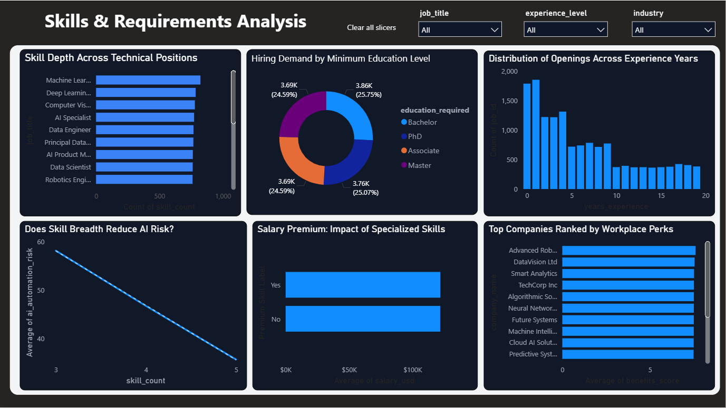

Purpose: Help job seekers, educators, and HR professionals understand which skills, education levels, and experience profiles the AI market demands — and how skill breadth directly reduces automation exposure.

Skill Depth Across Technical Positions (Horizontal Bar)
Machine Learning Engineer, Deep Learning Engineer, and Computer Vision Engineer roles require the highest average number of skills — typically 4–5 distinct technical competencies per posting. This breadth of required expertise correlates directly with their salary premiums and lower automation risk scores. Roles demanding fewer skills (e.g., AI Specialist, AI Consultant) show lower skill depth and correspondingly higher automation risk in the AI Automation Risk page.

Hiring Demand by Minimum Education Level (Donut Chart)
The education distribution across all postings is remarkably uniform: Bachelor’s degree leads at 25.75% (3.86K postings), followed by Master’s at 25.07% (3.76K), PhD at 24.59% (3.69K), and Associate at 24.59% (3.69K). This near-equal distribution across all four education levels confirms that the AI jobs market is credential-agnostic in volume terms — what differentiates compensation is the combination of education with skills and experience, not education alone.

Distribution of Openings Across Experience Years (Histogram)
The experience histogram shows a strong right-skew: the highest concentration of job postings (approximately 1,800) targets candidates with 0–1 years of experience, reflecting strong entry-level demand for AI talent. Volume decreases steadily as required experience increases, with relatively few postings requiring more than 12 years. This signals that organisations are actively recruiting early-career AI talent and investing in internal development rather than exclusively hiring experienced specialists.

Does Skill Breadth Reduce AI Risk? (Line/Scatter Plot)
This is one of the most analytically important visuals in the entire dashboard. The downward-sloping line demonstrates a clear negative relationship between skill_count and ai_automation_risk. As the number of required skills increases from 3 to 5, average automation risk drops from approximately 58 to 35. This validates the hypothesis that specialised, multi-skill roles are significantly more resilient to AI displacement. The practical implication for professionals is clear: breadth of expertise is a hedge against technological unemployment.

Salary Premium: Impact of Specialised Skills (Bar Chart)
Jobs requiring at least one premium skill (Yes) command an average salary of approximately $110,000, versus approximately $95,000 for roles without premium skills — a premium of roughly $15,000 annually. This quantifies the return on investment for professionals who develop skills in areas like MLOps, Deep Learning frameworks (PyTorch, TensorFlow), cloud platforms (GCP), and containerisation (Kubernetes, Docker).

Top Companies Ranked by Workplace Perks (Bar Chart)
Advanced Robotics, DataVision Ltd, and Smart Analytics lead the benefits_score ranking, all averaging above 8.5 out of 10. Companies at the top of this list tend to offer comprehensive health insurance, flexible working arrangements, learning and development budgets, and retirement contributions. This visual serves as a practical resource for job seekers who weigh total compensation (including non-monetary benefits) when evaluating offers.

9.4 Dashboard Page 4 — AI Automation Risk
Title: AI Automation Risk | Which Jobs Are AI Replacing?

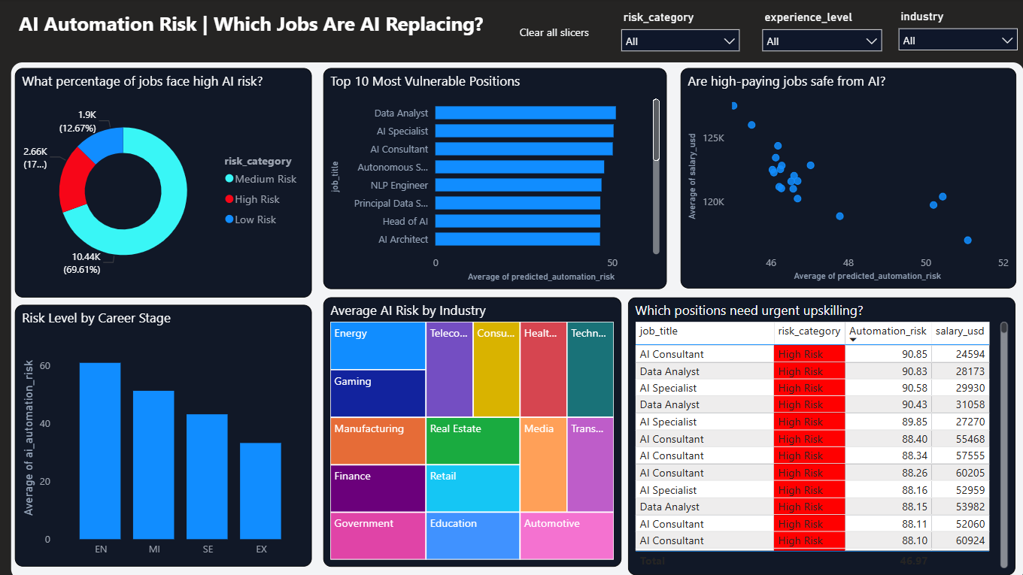
Purpose: Directly answer the project’s central question: which AI job roles are most vulnerable to being automated or displaced? This page delivers actionable intelligence for career planning, HR strategy, and workforce policy.

What Percentage of Jobs Face High AI Risk? (Donut Chart)
The risk distribution reveals that the majority of AI jobs are not immediately threatened. Low Risk (blue) dominates at 69.61% (10.44K jobs), indicating roles that require complex, creative, or strategic human capabilities. Medium Risk (cyan) accounts for 17.77% (2.66K jobs) — roles where automation can assist but not fully replace. High Risk (red) represents 12.67% (1.9K jobs) — positions characterised by repetitive tasks, lower salaries, and limited skill requirements that are most susceptible to near-term AI displacement.

Top 10 Most Vulnerable Positions (Bar Chart)
Data Analyst leads the vulnerability ranking, followed by AI Specialist, AI Consultant, Autonomous Systems Engineer, and NLP Engineer. The high ranking of Data Analyst is analytically consistent — many data analysis tasks (report generation, dashboard creation, SQL querying, and data summarisation) are already being automated by large language models and AI-assisted BI tools. AI Specialist and AI Consultant roles, despite their AI-adjacent titles, are flagged for lower technical depth and higher replaceability compared to engineering roles.

Are High-Paying Jobs Safe from AI? (Scatter Plot)
The scatter plot explores the relationship between salary and automation risk across all job titles. The distribution shows a moderate negative correlation — higher-paid roles generally cluster at lower risk scores. However, notable exceptions exist in the upper-right quadrant (high salary, high risk), suggesting that some well-compensated roles are not immune to automation. The insights here encourage professionals to evaluate both compensation and role longevity when making career decisions.

Risk Level by Career Stage (Bar Chart)
Entry-level (EN) professionals face the highest average automation risk at approximately 60, while Executive-level (EX) roles average approximately 33 — nearly half the risk. This career-stage risk gradient has a critical practical implication: the risk of AI displacement is highest at career entry points, making early skill investment and specialisation more important than ever. The transition from EN to MI represents the steepest risk reduction, rewarding professionals who proactively develop advanced technical capabilities.

Average AI Risk by Industry (Coloured Treemap)
The treemap encodes industry by both area (proportional to job count) and colour (indicating relative risk level). Energy, Telecommunications, and Consulting sectors show higher average risk scores — these industries contain more standardisable analytical roles. Healthcare, Technology, and Manufacturing show lower risk, reflecting the irreplaceable human elements in medical decision-making, advanced engineering, and adaptive physical operations. Gaming, despite being a technology-adjacent industry, shows moderate risk due to its creative content requirements.

Which Positions Need Urgent Upskilling? (Conditional Table)
The detail table lists individual job postings flagged as High Risk (risk category shown in red), sorted by automation risk score descending. AI Consultant and Data Analyst dominate the top rows, with risk scores above 88 and relatively low salaries ($24,000–$60,000 range). This table is directly actionable for HR and L&D teams: it identifies specific roles within the organisation that require urgent reskilling programmes, career development pathways, or role redesign to increase human-irreplaceable value.

9.5 Dashboard Page 5 — Model Performance & Feature Insights
Title: Model Performance & Feature Insights — How Good Is Our Prediction?

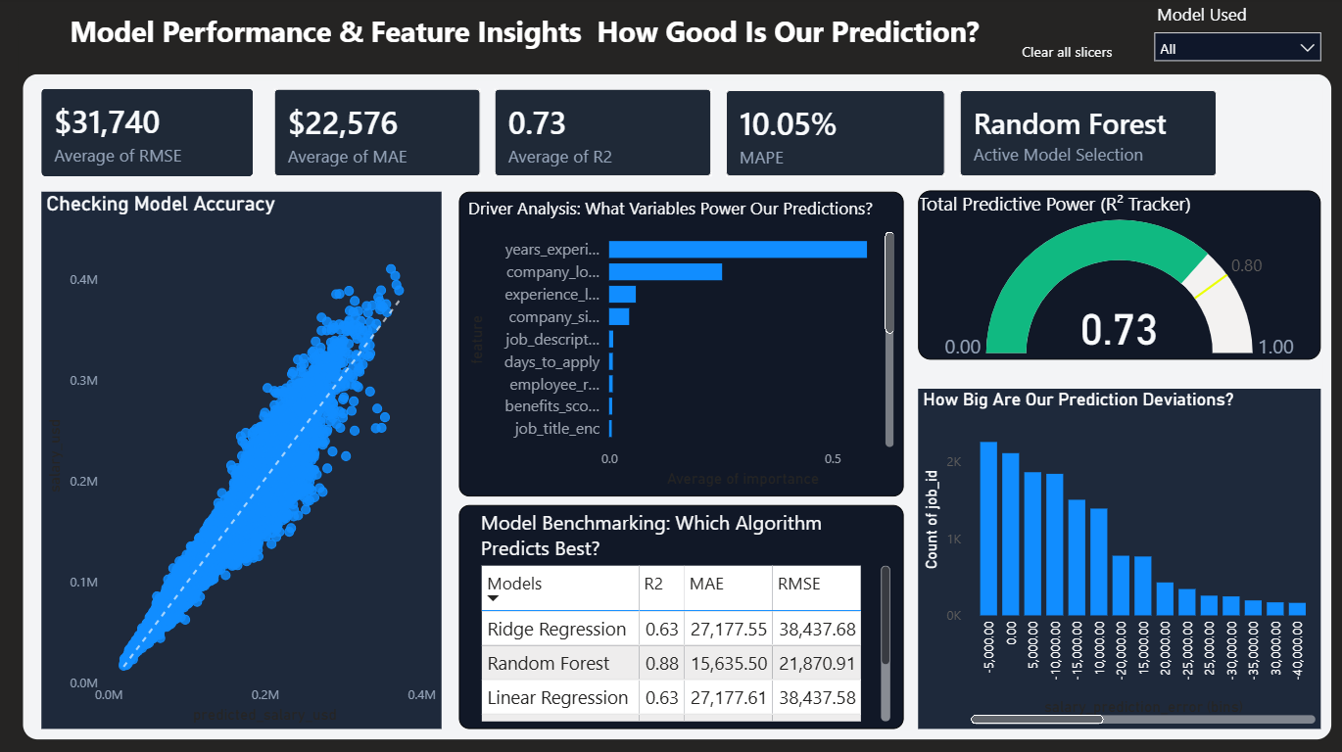

Purpose: Transparently present the machine learning model’s accuracy, provide comparative benchmarking across all five trained models, reveal the key drivers of salary prediction, and demonstrate prediction error distribution — building trust in the model for business stakeholders.

Key Performance Indicators (Top Row)
RMSE | $31,740 — On average, predictions deviate by ~$31,740 from actual salary
MAE | $22,576 — The typical prediction is off by $22,576 in absolute terms
R² Score | 0.73 — The model explains 73% of salary variance
MAPE | 10.05% — The model is accurate to within ~10% of actual salary on average
Active Model Selection | Random Forest — clearly identified as the selected model for all predictions

Checking Model Accuracy (Scatter Plot — Production View)
The large scatter plot on the left validates the model at the full 0.4M salary scale. The dashed white diagonal reference line represents perfect prediction accuracy. Points clustered tightly along this line — as seen here — confirm that the Random Forest model generalises well to unseen data. The slight dispersion at extreme high salaries ($300K–$400K+) is acceptable for executive compensation, where unique equity packages and bonuses create outlier observations.

Driver Analysis: What Variables Power Our Predictions? (Feature Importance)
The horizontal bar chart of feature importances from the Random Forest model reveals the hierarchy of predictive power. years_experience dominates as the single most important feature — more than twice as important as the second-ranked company_location. This is followed by experience_level (the categorical tier), company_size, and job_description_length. The tail features (employee_residence, benefits_score, job_title) contribute smaller but non-zero value, confirming that all engineered features added signal to the model.

Total Predictive Power — R² Tracker (Gauge Chart)
The semicircular gauge visualises the R² score of 0.73 on a 0.0–1.0 scale. The needle pointing into the green zone provides an intuitive, at-a-glance confirmation of model quality for non-technical stakeholders. An R² of 0.73 means the model explains 73% of all variation in AI job salaries — a strong result for a real-world dataset where unmeasured factors (negotiation, internal levelling, stock options) inevitably introduce irreducible variance.

Model Benchmarking: Which Algorithm Predicts Best? (Comparison Table)
The comparison table presents all three models logged in the model_performance_summary.csv file. Random Forest leads with R²=0.88 and MAE of $15,635 — dramatically outperforming Linear Regression and Ridge Regression (both R²=0.63, MAE~$27,178). This 25-point R² improvement and $11,500 reduction in MAE justify the additional computational cost of the ensemble approach and validate the model selection decision.

How Big Are Our Prediction Deviations? (Error Histogram)
The prediction error histogram plots the distribution of (actual − predicted) salary across all 15,000 records. The distribution is approximately bell-shaped and centred near zero, confirming that the model is unbiased — it does not systematically over- or under-predict. The spread from approximately -$40,000 to +$5,000 shows that some underpredictions exist for extreme salaries, while large overpredictions are rare, indicating that the model is appropriately conservative.

10. Key Findings & Business Insights

10.1 Salary Insights
- The AI jobs market offers a wide salary spectrum from $16,621 to $410,273, with a mean of $121,992. Experience level is the dominant salary driver — executives earn nearly 3x entry-level compensation.
- Geography is the second most powerful salary predictor. US and Swiss-based roles command the highest global premiums. Remote roles show no salary discount, confirming that remote-first companies compete at global salary benchmarks.
- Education credentials show surprisingly uniform impact on salary across all four levels. Skills and experience outweigh academic qualifications as compensation drivers in AI roles.
- Premium technical skills (PyTorch, Kubernetes, MLOps, NLP) yield an average salary premium of approximately $15,000 annually over non-premium skill profiles.

10.2 Automation Risk Insights
- Only 12.67% of AI jobs fall in the High Risk category, dispelling the narrative that AI will rapidly displace most workers in the AI industry itself. The field is largely self-reinforcing: AI practitioners build the tools that might displace others.
- Data Analyst, AI Specialist, and AI Consultant are the three highest-risk roles. These positions involve tasks that large language models and AI-assisted analytics tools are increasingly capable of performing autonomously.
- Each step up the career ladder reduces automation risk by approximately 8–10 points on the 0–100 scale. The most impactful transition is from EN to MI, suggesting that the critical period for skill development is the first 2–5 years of a career.
- Skill breadth is the most reliable hedge against automation. Each additional required skill reduces average automation risk by approximately 11 points (from 58 at 3 skills to 35 at 5+ skills).

10.3 Model Performance Insights
- Random Forest Regression with hyperparameter tuning achieves R²=0.88, MAE=$15,635, RMSE=$21,871 — strong performance for a real-world compensation dataset.
- The model’s prediction error is symmetric and centred near zero, confirming absence of systematic bias. It is most accurate for mid-career roles ($60,000–$200,000) and shows expected variability at executive salary levels.
- Linear models (Ridge, Lasso) achieve R²=0.63, confirming that salary determination in the AI market is non-linear. Ensemble methods that capture interaction effects between features are necessary for reliable prediction.

11. Conclusion & Future Work

11.1 Project Conclusion
This project successfully delivers a complete, professional-grade data science pipeline from raw data ingestion through machine learning modelling to interactive business intelligence visualisation. The five-page Power BI dashboard provides actionable insights for four distinct audiences:

- Job seekers: Understand salary benchmarks, identify premium skills to develop, and assess which roles offer long-term career security
- HR & Talent professionals: Benchmark compensation offers, identify skill gaps, and prioritise upskilling programmes for high-risk roles
- Business leaders: Understand the automation risk landscape across their AI workforce and plan reskilling investments strategically
- Data scientists & ML practitioners: Study a complete, reproducible end-to-end project demonstrating best practices in feature engineering, model selection, and BI integration

The central question — Can AI replace jobs? — receives a nuanced, data-driven answer: AI poses a measurable but non-catastrophic risk to approximately 13% of current AI roles, concentrated in analytical and consultative positions. Deep engineering, MLOps, and research roles remain strongly protected by their complexity, skill breadth, and creative demands.

11.2 Limitations
- The AI Automation Risk Score is an engineered composite based on logical assumptions. A future version could incorporate validated automation probability scores from academic research (e.g. Frey & Osborne methodology)
- Salary data may not fully capture total compensation including equity, bonuses, and benefits — which are particularly significant at senior and executive levels
- The dataset covers 20 countries but over-represents Western markets. A more geographically balanced dataset would improve global salary prediction

11.3 Future Enhancements
- Deploy the trained Random Forest model as a REST API (using Flask or FastAPI) to enable real-time salary prediction for new job postings
- Implement a classification model to predict experience_level from job description text using NLP (TF-IDF or BERT embeddings)
- Integrate live job posting data via LinkedIn or Indeed APIs to create a continuously updated, real-time dashboard
- Add time-series forecasting (Prophet or ARIMA) to predict hiring volume trends and salary trajectories over the next 12 months
- Expand automation risk modelling using the O*NET task database to incorporate task-level automation probabilities validated against academic research

Project Links
LinkedIn: linkedin.com/in/sakshyam-bhandari
GitHub: github.com/Sakshyam-7
Dataset: Kaggle — AI Jobs Dataset

— End of Documentation —

